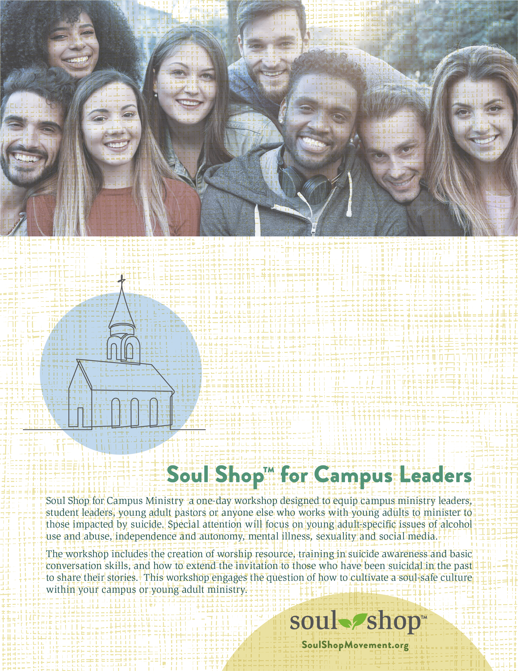

June 22, 2023
8:30am - 4:00pm

Radiant Church
4870 Piedmont Ave, N.
Charleston, SC 29406

Free admission
For further information:
John Tjaarda
JTjaarda@AFSP.org
803-528-4315

To register, visit:
https://ssclsc.attendease.com/

